WCU Rules for Online Chess Events

1 General Rules
1.1 All entries must be done via the WCU website.
1.2 The event is open to all.
1.3 All participants should agree to having their name, age, gender, nationality, title and rating to be shown on any official WCU owned website. Those wishing to withhold their consent will not be allowed to take part in the event.
1.4 The exact format and structure of the event will be determined by the WCU Executive Director and the Director of Home Chess. The structure of the event may change once the final entries are known.
1.5 New members will be accepted up until half an hour before the start of round 1.
1.6 Players who have been repeatedly banned by the host platform (more than twice), will not be permitted to enter the event.
1.7 Players will only be accepted to the lichess group if they are included on the WCU entry list.
1.8 The games will NOT be WCU rated.

2 Platform
2.1 The event will be hosted on lichess.
2.2 If players have existing accounts, then that is the one to be used for entry. Players are NOT allowed to have more than one lichess account.
2.3 Players must agree to having their real names disclosed so that it is clear to all, who they are playing.
2.4 Participants are advised to become familiar with the sites own rules. Pay particular attention to the rules of fair play, sportsmanship and online conduct. Details can be found here.

3 Anti-cheating
3.1 lichess’s anti-cheating software will be in use for all games. Players must make themselves familiar with lichess’s rules and the consequences if malpractice is discovered. Details can be found here.
3.2 The WCU will not be held responsible if lichess bans or flags a player.
3.3 The WCU forbids the use of any 3rd party advice, whether by engine, books, advice from another player or coach.
3.4 Players must not use other people’s accounts.
3.5 Players must not interfere with any other games in the event, this includes use of the chat function.
3.6 Items 3.4-3.6 are not an exhaustive list. The WCU will consider any other means that are used to aid the player, as appropriate.
3.7 The WCU will send ALL games that are played for scanning to Prof. Ken Regan. He has developed a sophisticated anti-cheating program which is endorsed by FIDE.

4 WCU Sanctions
4.1 Any sanctions that are applied by the WCU will vary depending on the severity, circumstances and the number of occurrences of the offence.
4.2 The list of sanctions is listed below
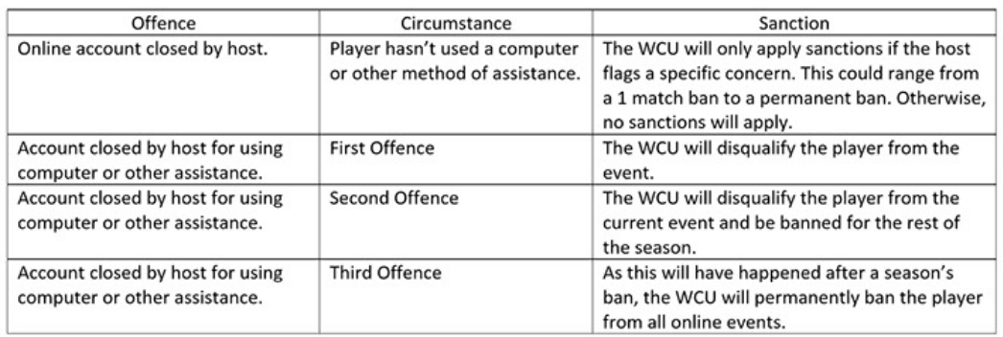

4.3 The sanctions will apply from the round immediately following on from the round where the offence was reported.
4.4 Players will be informed of the sanction and be advised that an appeal can be made.
4.5 The WCU will not publish the name of the player being sanctioned.
4.6 The player’s results will not be removed in the interests of protecting a sanctioned players anonymity.

5 Appeals
5.1 An appeal against sanctions, can only be made to the WCU after a player has appealed to lichess and it has been denied.
5.2 If a player is banned or flagged by lichess they should decide whether to appeal. This must be directly to lichess and done as soon as possible.
5.3 The WCU appeals board will consist of zonal reps plus a technical expert on anti-cheating. The panel can co-opt a player of sufficient strength, e.g. a GM, to provide an opinion as to whether they agree that computer assistance was used.
5.4 The results from the scanning of games by Ken Regan’s software, can be made known to a player who has appealed against a sanction.
5.5 If the appeal is successful, then the player will not be sanctioned.
5.6 If the appeal is successful, then the player, subject to the host platforms rules, will be allowed to create a new account on the host platform and to compete in future competitions.
5.7 The WCU will not provide damages to a player where their appeal has been successful.
5.8 There will be a cost of £50 by the player for the appeal. This will be refunded if the appeal is upheld.

6 Disconnections and Other Issues
6.1 If a player gets disconnected, then their clock continues to run until flag fall.
6.2 A loss by connection for a second time will result in a yellow card warning.
6.3 A loss by connection for the third time will result in a red card and the player is eliminated from the event.
6.4 In the case of a red card, the player’s results will stand.
6.5 If your opponent can't reconnect, lichess will present you with an option to claim the game or to accept a draw. It is up to the player which to choose.

